**Problem 1:** Parameterized Constructor in Java.

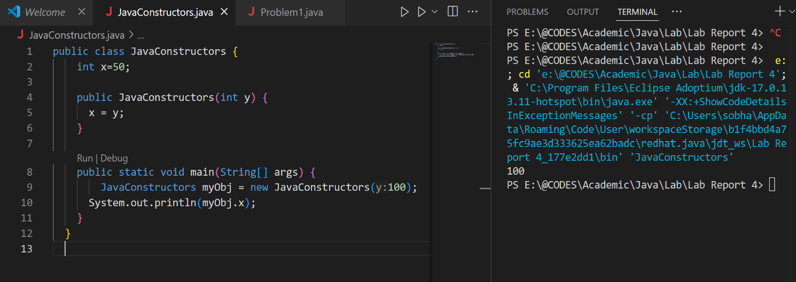

**Problem 2:** Demonstrating Encapsulation with Private and Public Variables.

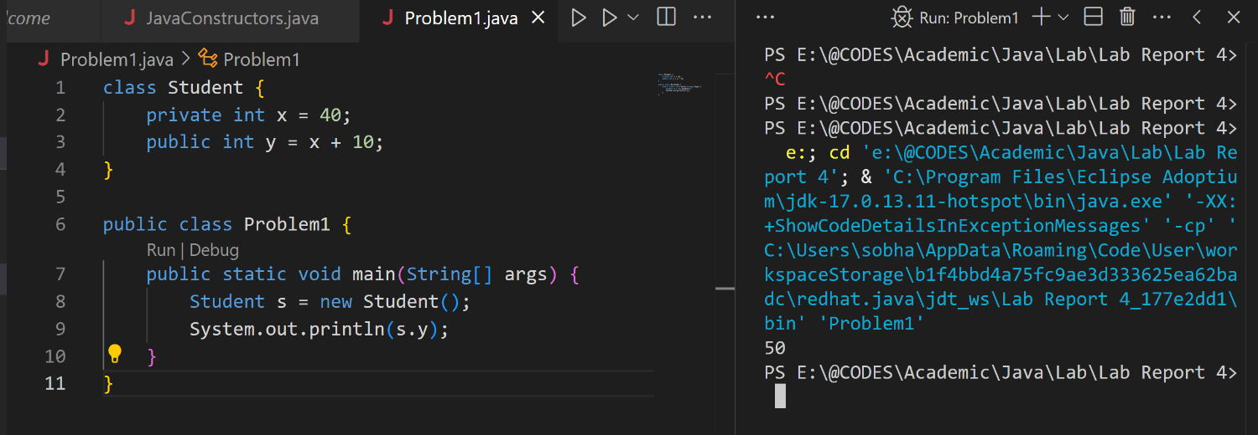

**Problem 3:** Using Default Constructor and Method to Display Value.

